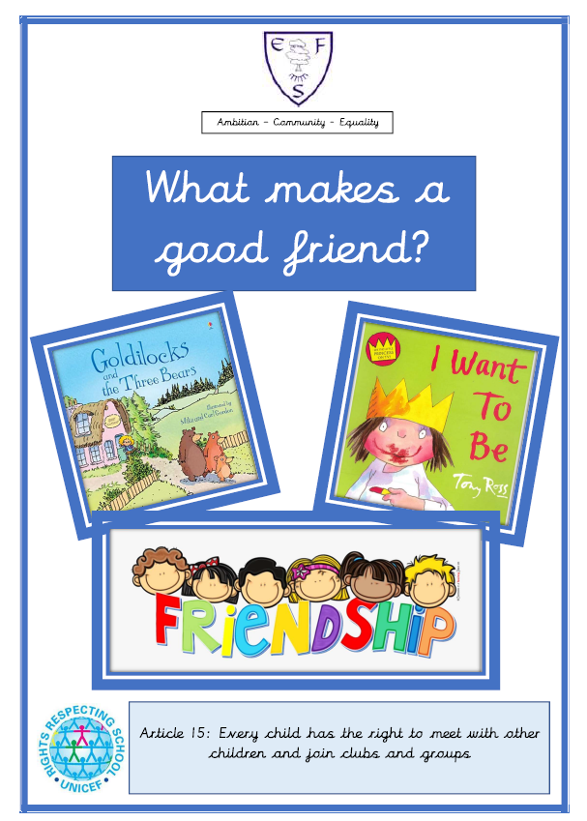
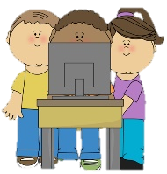
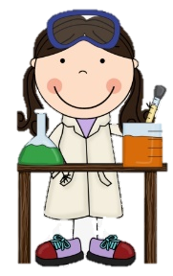
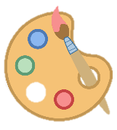
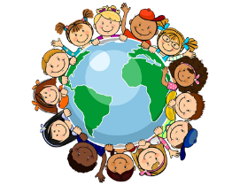
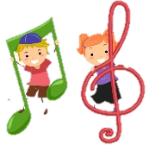
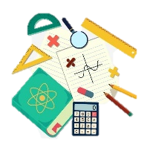
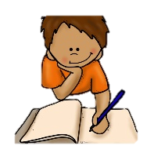

RE
In RE we will be learning how to share and take turns.
PSHE
During PSHE lessons this half term we will learn how to keep ourselves safe.

English
Class texts:
- Dear Daisy
- Goldilocks & The 3 Bears
- I want to be!

Children will be learning to show an interest in books and illustrations and handle books with care.
Maths
This half term’s foci are:
- Noticing and arranging things in patterns
- Taking part in finger rhymes with numbers
- Completing inset puzzles

Geography
We will be learning about the people around us.
History
We will be listening to stories and following what happens over time.
Art
We will be making marks with different materials
DT
We will be exploring different toys around the classroom.

Music
In music, we will be responding to music with movement.
Computing
We will be exploring the Interactive Whiteboard
PE
This half term’s focus is:
Finding space and changing direction and speed.

Tuesday

Ambition-Community-Equality
What your child will be learning:
Nursery Autumn Term 1

Science
In our science lessons we will be thinking about what our bodies need i.e. toilet, water, food.

