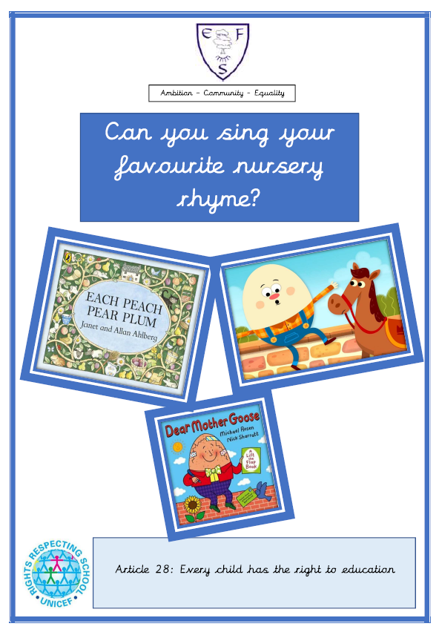

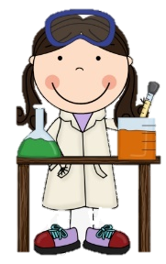
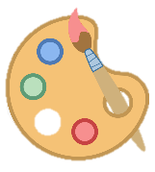
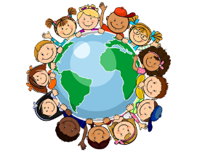
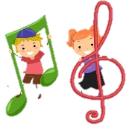
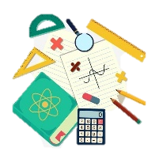
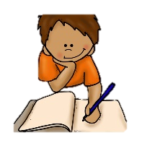

RE
In RE we will be learning about the Christmas story.
PSHE
During PSHE lessons this half term we will learn about our body parts and movement.

English
Class texts:
- Each Peach, Pear Plum
- Dear Mother Goose
- Humpty Dumpty

Children will be learning to repeat familiar songs and phrases from stories and developing play around familiar stories using props.
Maths
This half terms foci are:
- Developing counting like behaviour
- Count in everyday contexts
- Comparing amounts using more, lots and same.

Geography
We will be exploring the environment around us.
History
We will be looking at how we have changed over time.
Art
We will continue to make marks with different materials
DT
We will be exploring foods that we like.

Music
In music, we will be singing familiar songs and nursery rhymes
Computing
We will be using the Interactive Whiteboard pens to draw.
PE
This half term’s focus is:
Moving in different ways
PE lessons will take place on: Tuesday

Ambition-Community-Equality
What your child will be learning:
Nursery Autumn Term 2

Science
In our science lessons we will be exploring what happens when a character falls
(Humpty Dumpty.)

