ELMS FARM PRIMARY SCHOOL
ENGLISH
CURRICULUM EXPECTATIONS

EXPECTATIONS: ENGLISH

WRITING

Lesson structure

- In Key Stage Two, most children should write the full date for every lesson.
- Each lesson should have a title that summarises the main focus of the learning. There is no need for an LO. While success criteria are not necessary in all lessons, they may be used to support learning where necessary.
- Short grammar-focussed tasks should take place daily. These should be planned from using national curriculum or used to address misconceptions.
- In each lessons all children will have an opportunity to practise their handwriting in their English books. Teachers should refer to the Elms Farm Handwriting Pathway for planning guidance.

General principles

- Talk is central to the Elms Farm Talk for Writing process. Teachers should provide regular opportunities throughout lessons for children to learn from talk and learn through talk. They should use the Voice 21 Talk Tactics to develop discussions and deepen understanding. Teachers should use a range of groupings to ensure all children are engaged in each stage.
- High quality questioning should be used to assess throughout the process.
- All learning should be building upon prior knowledge to develop and strengthen schemas. Potential misconceptions should be anticipated in the planning stage. If misconceptions occur, teachers will act swiftly to adapt their lesson and address the issue.
- The Talk for Writing teaching sequence utilises a gradual release of scaffolding model so that children build skills over the course of the unit and use them to write their own texts. This route can be summarised as using an expert model text > working collectively to innovate that text > moving to independent work to invent a new version of the text.
- This movement from support to independence should be planned into teaching sequences. For example: introduce a new term such as fronted adverbial, locate it in the model text, use it in practice activities, apply it into writing.
- Staff should model high expectations for handwriting, vocabulary use, spelling and grammar at all times.
- Staff should use Hot Writes as assessment opportunities and to reflect and plan for the next teaching sequence. Assessment must take place using the assessment criteria grids.

Elms Farm Talk for Writing sequence
Preparing to teach
- Teachers refer to the Long-Term Plan (Curriculum Overview) to find the unit of work to be covered.
- From the long-term plan, teachers will create a ‘knowledge organiser’ in which they will identify the objectives that need to be covered and that are relevant to the text type/ purpose of writing. On this document, they will also identify key vocabulary and skills (from the linked T4W toolkit).
- Teachers should consult the following documents: EFPS Key Vocabulary Grid, EFPS T4W Toolkits and the EFPS Story Structures to find clarification and further information about the planning sequence. If more support is needed, teachers should seek support from the English Lead.
- Teachers create a model text that fits both the features of the text type and exemplifies the objectives that children need to achieve.
- Teachers will seek clarification about any terminology or subject knowledge gaps they may have so that all relevant grammar is taught correctly and so that text types demonstrate the relevant features.
- Teachers will plan opportunities to develop and deepen understanding through oracy.

The Imitation Stage
- The unit of work is introduced to the children through the hook. This could be through watching a video, reading high-quality books, undertaking drama or participating in tactile experiences. When the model text will be a short version of a longer story (e.g. a Greek myth), then sharing a longer, richer version of the story should be considered. The hook should be practical, using oracy to develop ideas and engage in meaningful discussion.
- A knowledge organiser is shared with the children. This includes the name of the unit, the type of writing that will be produced (including a description of the text type), key vocabulary that will be used and what children will have learned by the end of the unit. This will help children to understand what they are learning and to focus teachers on the key skills being taught.
- The model text is shared with the children. This should not yet be colour coded.
- Teachers may create text maps to help the children read and recall the text.
- The text will be read and re-read by the class over a series of days. Approaches such as teacher reading, choral reading and echo reading, etc. should be used to support reading and to provide variety and interest to the class. In Key Stage 1, children will use actions to support them in retelling the text. In Key Stage 2, this stage should not be over-looked. It is an excellent opportunity to practise reading fluently and expressively. Teachers will ensure that other learning activities take place during lessons and that reading and re-reading the text does not fill a whole lesson. In some lessons, children may re-read and rehearse part of the story to keep a tight focus.
- Playful and creative learning techniques will be used to explore some of the language patterns in the text. For example, you may want to focus on specific vocabulary by playing word association, or using ranking to assess the power of the words in the text.
- Oracy will play an essential role in developing children’s understanding of unfamiliar vocabulary. Voice 21 Oracy talk tactics and inclusive groupings will be used to develop and deepen understanding. Children will have many opportunities to practise using a wider range of language patterns during the learning sequence.
- Teachers will use the model text as a framework from which to teach spelling, vocabulary and grammar work. All activities will support the aims of the unit. Where possible, oracy activities will support this learning.
  - Spelling will be linked to the ongoing No Nonsense Spelling work and common errors made by the class.
  - The vocabulary to be taught will be selected by the teacher at the planning stage. This will use the principles of the Tiered Approach to language learning so that essential content/ technical vocabulary (Tier 3) is clarified and focussed work on versatile language (Tier 2) takes place over a series of days.
  - Grammar work will support understanding of the text and where possible be pitched at the year group objectives.
  - Key spellings, content/technical words, tier 2 words and examples of focus grammar will be displayed on the working wall/ in the setting.
- Key features and writerly techniques will be colour coded and annotated with the children. Teachers should be mindful that the amount of colour coding and annotation should be manageable and that these sessions should be timely and efficient.
- The text will be displayed on the line.

Teachers should not rush the imitation stage of the Talk for Writing process. Time spent on reading the text, learning about its features and practising them through short writing activities will support the children when they come to write their own innovated and invented texts.

The Innovation Stage
- Teachers ensure that children have sufficient knowledge to begin innovating using the structure of the original text. This could mean providing a new hook. For example, where the original text was a recipe for making beans on toast and the children are innovating on this to write a recipe for cheese on toast, they would clearly benefit from making cheese on toast so they can draw on this experience.
- Teachers will collate any new vocabulary or spellings the children may need and display these in the learning environment.
- Children should use their boxed-up plan to add new and important information to help them with their innovation. Teachers should model doing this. Teachers should be mindful of the planning format they choose. While the box-up method should be the standard, it does not lend itself to some text types. Teachers should consult the English Lead for support to choose the best planning format if unsure.
- Playful and creative learning activities will continue to be used by teachers to secure key knowledge that will support children’s writing.
- Teachers use shared writing to create a new text with the children. They will build on examples from the model text. Children will be encouraged to use their oracy skills to engage in discussion and debate, building on one another’s ideas and borrowing their favourites to use in their own writing. For this, a magpie sheet or mini-whiteboard could be used.
- Teachers will also use modelled writing. They will demonstrate key writing skills to children while explaining their choices. They will make planned and deliberate errors to help children see the writing process in action and to model how to reread texts.
- The shared (and modelled) text is displayed clearly so that children can use it to support their own writing.
- Teachers may choose to create a whole or partial text with their children (based on their knowledge of what the children need). If choosing to model parts of their text, teachers will need to be mindful that they don’t model only beginnings.
- Children write their own texts using the original model, the boxed-up plan, the working wall and the shared/modelled writing to support them. Teachers are likely to want to plan this to take place over a series of days after the shared/modelled writing.
- Teachers should model how to revise and edit text, creating their own texts for this purpose. They should ask children to revise and edit sections of their text rather than their entire texts. Children can work in pairs to do this.

The Invention Stage
- Children will invent their own version of the model text. This will be used to assess their application of what has been taught in the unit. It is the Hot Write.
- The Hot Write should take place at a distance from the teaching sequence. A space of at least a week should be made.
- The children will need time to plan their invented text and then write it.
- More able children should be challenged to write their invention story in different ways. For example, they could write from a different perspective, write a text within a text (a newspaper cutting within their story) or write the ending first.
- During the writing process, all children should be encouraged to orally rehearse sentences before writing using ‘nest time’.
- Teachers should use the invented text to assess learning of the objectives taught in the unit. It will also provide information about broader aspects of English including spelling, vocabulary and how well children have embedded key grammatical skills from other teaching sequences.
- The Hot Task will also help form the teachers’ knowledge of what their children can do and where gaps in their learning exist.
- Children should have the opportunity to revise and edit their Hot Tasks. This will help them learn from the mistakes that they make. They should also be given the opportunity to bring their writing to a published standard and to share it in different ways.
- Teachers should use writing undertaken in other curriculum areas as evidence of how well children have embedded skills taught in English. This will include their ability to write for different purposes and their application of vocabulary, spelling, grammar and punctuation.

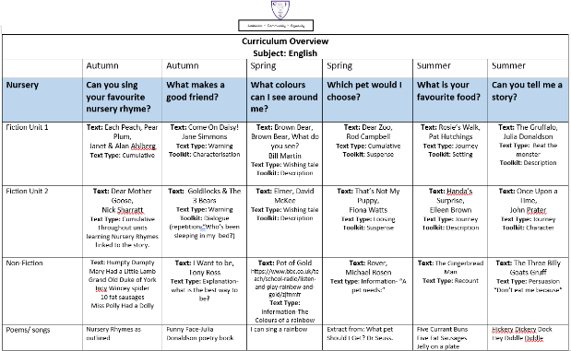

READING:
Home Reading Books
- Teachers must set the home reading book for all children, including SEND children and newly-arrived children.
- In KS2, teachers will read with children to check their home-learning level. All pupils must have a home reading book suitable for their reading stage and fluency-this must be set be the class teacher. Children should select books from their assigned band from their class library. Children may access books from other class’ libraries if a different stage is required.
- Pupils will be heard reading by their teacher at least once every two weeks.
- If a child has not passed their KS1 phonics test, they will be supported through intervention. The books they read must be matched their phonological reading stage. They should also have a book for pleasure.
- Use assembly times on Tuesday morning to read with children. LSAs will remain in the hall.
- Staff read and recommend texts to children based on their interests.
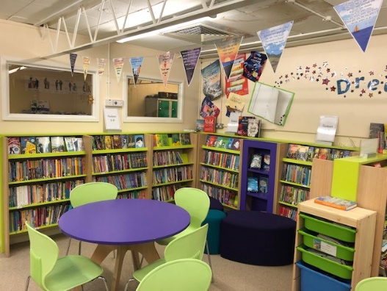
- E.Y.F.S & KS1 pupils should have decodable books linked to their Phonics Lessons. In Y2, pupils may progress to short chapter books when they are confident at GPC.
- All pupils are expected to read at least 5 times per week, tracked by home reading charts. Tracking should be done discreetly and with compassion to those children who are not supported at home. Staff must identify and implement actions for any pupil not reading at home. Staff will initial, stamp or sticker diaries.
- Teaching staff are encouraged to promote a love of reading through ‘book talk’ and through daily reading sessions (3:00-3:25).
- Library visits: All children are expected to access the library once a fortnight to take out a book to read ‘for pleasure’. Book choices should be supported by the teacher but should not be limiting.
- During library visits, books must be scanned in and out. Pupils who do not return books will be issued with a reminder letter.
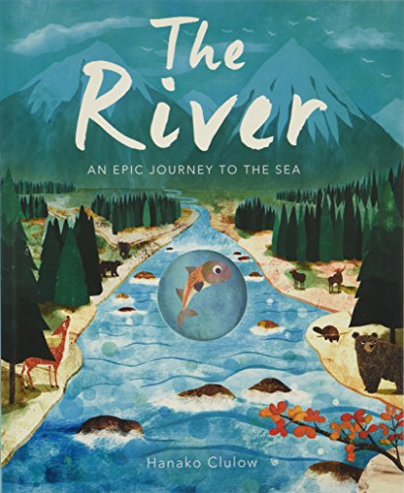
- Children who have read daily for two weeks will be given a reading certificate. The English Lead will hand these out.
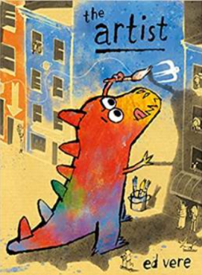
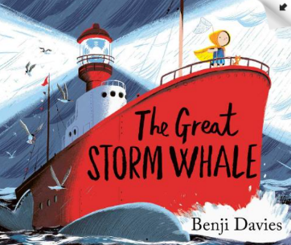
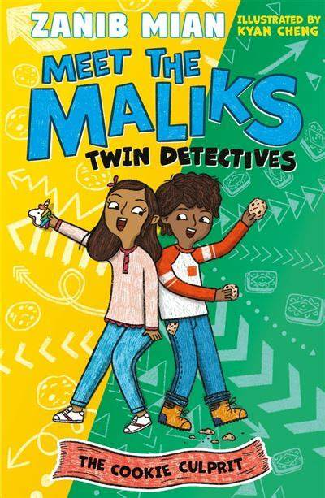
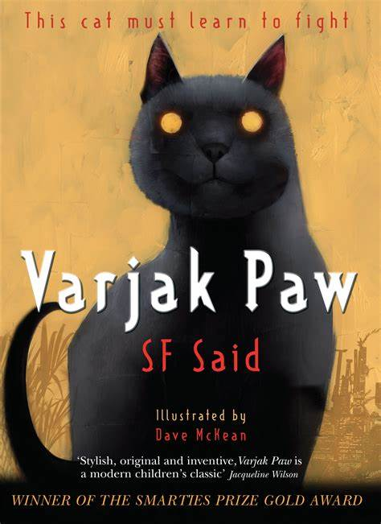
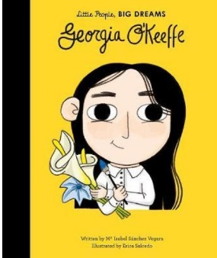

Group reading in EYFS and KS1
Teaching reading: Reading practice sessions three times a week
- We teach reading practice sessions three times a week. These:
-are taught by a fully trained adult to small groups of approximately six children
-use books matched to the children’s secure phonic knowledge using the Little Wandle Letters and Sounds Revised assessments and book matching grids on pages 11 to 20 of ‘Application of phonics to reading’
-are monitored by the class teacher, who rotates and works with each group on a regular basis.
- Each reading practice session has a clear focus, so that the demands of the session do not overload the children’s working memory. The reading practice sessions have been designed to focus on three key reading skills:
-decoding: teaching children to use phonic knowledge to read words
-prosody: teaching children to read with understanding and expression
-comprehension: using dialogic talk to help children to understand the text.
- In Reception, these sessions start in Week 4 of teaching at the latest. Initially, children will read wordless books. In these sessions, children review GPCS and are taught blending using teacher-led blending. Once children can blend, they progress onto decodable books matched to their secure phonic knowledge.
- Children read each book three times to develop phonemic awareness, vocabulary and comprehension as well as book behaviours.
- In Year 2, we ensure children complete reading the core programme decodable books (up to Phase 5 Set 5). To exit the programme, we complete the final fluency assessment to ensure children can read with adequate speed and accuracy: approximately 60 words per minute with 90%+ accuracy.
- Reading in Rapid Catch-up lessons mirrors the core programme. Children following the Rapid Catch-up programme are taught to read using the 7+ fully decodable books. These follow the same progression as the core programme but are more appropriate for older readers.
Day 1 | Day 2 | Day 3
Decoding and reading aloud. | Return to the text for retrieval (1b) and inference (1d)  These skills should be alternated as appropriate. | Read the text with prosody.  Concentrate on fluency and expression.

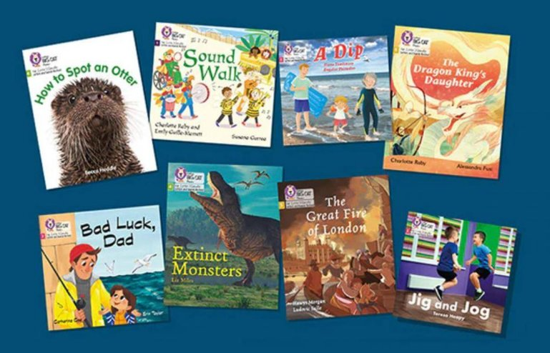

KS2 Whole Class Reading

- Teachers use the Reading Skill Progression and Text Maps to locate the texts for each half term.
- Planning must focus on the reading domains. We use the DERIC reading skills and characters to teach children about each reading skill.

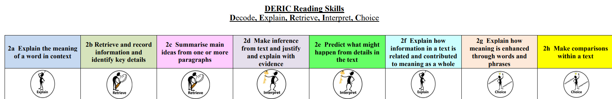

- All planning must be informed using AfL and prior reading of the text.

 | Monday | Tuesday | Wednesday | Thursday
KS2 | Vocabulary exploration and shared reading (2a)  Perform | Return to the text for retrieval (2b) and inference (2d) | Return to the text for mastery session (predict 2e/relate 2f/compare 2h) | Other focus skill (could be another extract) (Sequence and summarise 2c/Explore choice of words 2g)

- All children, at all level of ability must be involved in the whole class lesson

Vocabulary-Reading
- Teachers identify vocabulary from texts to teach explicitly. For wider curriculum areas, topic specific vocabulary is highlighted in Long Term and Unit Planning. All vocabulary instruction allows children to explore the morphology and etymology of words, including building word families.

- Vocabulary teaching is progressive and systematic: words which are challenging for the age of children are introduced on a weekly basis. These are discussed, defined and used frequently. All children should know their meanings and be encouraged to use them. These should be words particularly useful for the week’s writing unit, although they should be tier two words and not subject-specific words. These words remain on display and are added to. Elsewhere in the room, subject-specific vocabulary should be displayed and referred to.

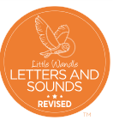
PHONICS

From Nursery we teach reading through Little Wandle Letters and Sounds Revised, which is a systematic synthetic phonics programme. We start teaching Little Wandle Foundations in our Nursery and then, from Reception, we follow the Little Wandle Letters and Sounds Revised progression, which ensures children build on their growing knowledge of the alphabetic code, mastering phonics to read and spell as they move through school.
Foundations for phonics in Nursery
- We provide a balance of child-led and adult-led experiences for all children that meet the curriculum expectations for ‘Communication and language’ and ‘Literacy’. These include:
  - sharing high-quality stories and poems
  - learning a range of nursery rhymes and action rhymes
  - activities that develop focused listening and attention, including oral blending
  - attention to high-quality language.
- We ensure Nursery children are well prepared to begin learning grapheme-phoneme correspondences (GPCs) and blending in Reception.
- Little Wandle Foundations is aligned to the non-statutory guidance on Development Matters and Birth to 5 Matters as well as the Early Years Foundation Stage (EYFS) statutory framework. We use it as part of our wider provision for Communication and Language, and Literacy. It supports children to:
-develop their phonological awareness, including rhyme, alliteration, syllables, initial and voice sounds, and oral blending
-love stories and rhymes, and learn by heart a bank of familiar favourites
-increase their vocabulary and confidence to talk
-improve their listening and ability to take part in back-and-forth conversations.

Language and nursery rhymes in Reception
- We use the Little Wandle Rhyme time films and accompanying phonological awareness planning to complement and reinforce our Phase 2 teaching.

Daily phonics lessons in Reception and Year 1
- We teach phonics for 30 minutes a day. In Reception, we build from 10-minute lessons, with additional daily oral blending games, to full-length lessons as quickly as possible. Each Friday, we review the week’s teaching to help children become fluent readers.
- Children make a strong start in Reception: teaching begins in Week 2 of the Autumn term.
- We follow the Little Wandle Letters and Sounds Revised expectations of progress:
-Children in Reception are taught to read and spell words using Phase 2 and 3 GPCs, and words with adjacent consonants (Phase 4) with fluency and accuracy.
-Children in Year 1 review Phases 3 and 4 and are taught to read and spell words using Phase 5 GPCs with fluency and accuracy.

Daily Keep-up lessons ensure every child learns to read
- Any child in Reception and Year 1 who needs additional practice has Daily Keep-up support and is taught by a fully trained adult.
- Daily Keep-up lessons follow the Little Wandle progression and use the same procedures, resources and mantras, but in smaller steps with more repetition so that every child secures their learning.

Daily phonics and spelling in Year 2
- Year 2 begins by using assessment to ensure that children have completed the Little Wandle Year 1 progression. Any gaps in teaching are addressed through daily phonics lessons until the programme is completed. Corresponding summative assessments are carried out to ensure this content is secure.
- Once all the Year 1 content has been taught and assessed, we teach a five-week Phase 5 review. This ensures that children secure the trickier elements of Phase 5 and can apply this alphabetic knowledge in both reading and spelling.
- We use the Phase 5 review assessment before teaching in Year 2 to identify any children who may need more support when teaching. We reassess after teaching the Phase 5 review.
- Children with larger gaps in their phonic knowledge than their peers have daily phonics teaching and follow the Rapid Catch-up programme.

Children in Year 2 to Year 6: Rapid Catch-up
- We timetable daily phonics lessons for any child in Year 2 and above who is not at age-related expectations for reading or has not passed the Phonics Screening Check. These children urgently need to catch up, so the gap between themselves and their peers does not widen.
- These short, sharp lessons last 15 to 20 minutes daily and have been designed to ensure children quickly catch up to age-related expectations in reading.
- We assess children who are new to our school, new to the country or new to English using the Rapid Catch-up assessments to quickly identify their needs.
- We use the Rapid Catch-up assessments to identify the gaps in children’s phonic knowledge and teach these using the Rapid Catch-up resources – at pace.
- We assess children every four weeks using the Rapid Catch-up summative assessments to assess progress and inform teaching.

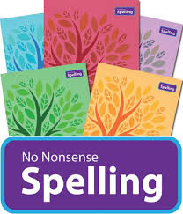
SPELLING
In years 2-6 the No Nonsense Spelling scheme is used to plan from. Each term, the medium term plans are used and additional sessions planned for. These additional sessions may also be used to address any gaps and weaknesses from previous year groups’ content. Plans and resources are adapted and annotated to suit the needs of the class in order to provide 5 x 15 minute lessons per week. Each child should use their spelling journal to practise the spelling rule at home.
Children are sent spelling patterns including words following the week’s taught spelling pattern, alongside common exception words from the year group word lists (NC). These spellings are then tested through dictations at the end of the week, including unlearnt words in which they must apply the taught spelling rule. These dictations also test the application of punctuation expected of that age group. They are to be recorded in the English book either at the start or end of the day’s writing, under the same date. The children are given a score and these are recorded on a class chart and next week’s word list to inform parents. Low scores and those that do not improve are addressed through conversations with parents and additional support. Children also complete an NFER Spelling test each term.
In writing in any subject, common exception words and taught spelling patterns are addressed (see marking of spelling guidance). Feedback and marking demonstrate that basic errors are addressed, requiring children to act upon their spelling mistakes. Verbal and written feedback encourage children to apply their taught knowledge of spelling patterns.

HANDWRITING
The Elms Farm Handwriting Pathway is used to plan opportunities for handwriting development across EYFS, Key Stage One and Key Stage Two. Teachers use the pathway document to identify the letters and joins they should be teaching in each term. Teachers use this document in conjunction with their teacher judgement to ensure good progress for all children.
Handwriting practise should take place daily and must be recorded in English books. Children will also have opportunities to practise handwriting in dictation.
Where possible the font CCW Cursive Writing 19 should be used to produce resources and displays. Teachers should model this handwriting on the board and when giving written feedback. When children are able, they should be encouraged to join their writing.
Pencil must be used until their handwriting is deemed to be an acceptable standard. At this point, child is sent to a member of SMT, who will then see three pieces of work and award them a handwriting pen.
Aa Bb Cc Dd Ee Ff Gg Hh Ii Jj Kk Ll Mm Nn Oo Pp Qq Rr Ss Tt Uu Vv Ww Xx Yy Zz
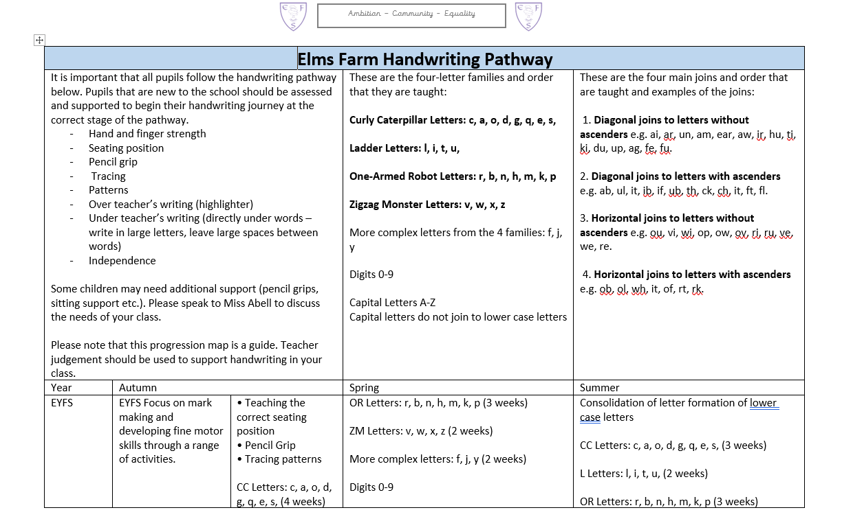
All exercise books are available with a progressive line guide. Teachers should assess pupils’ handwriting to provide the correct line guide for all subjects. Teachers will assess when children can progress onto different line spacing with the aim for all pupils to use EX04 by Year 5.

Examples of handwriting

Year 1
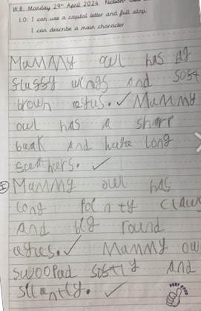
Lower Key Stage 2
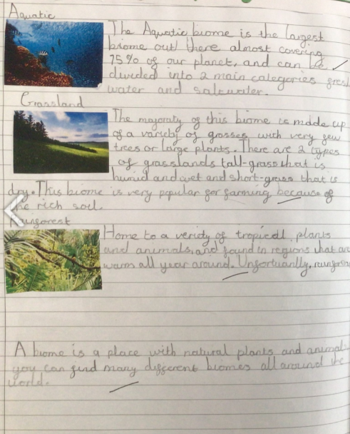
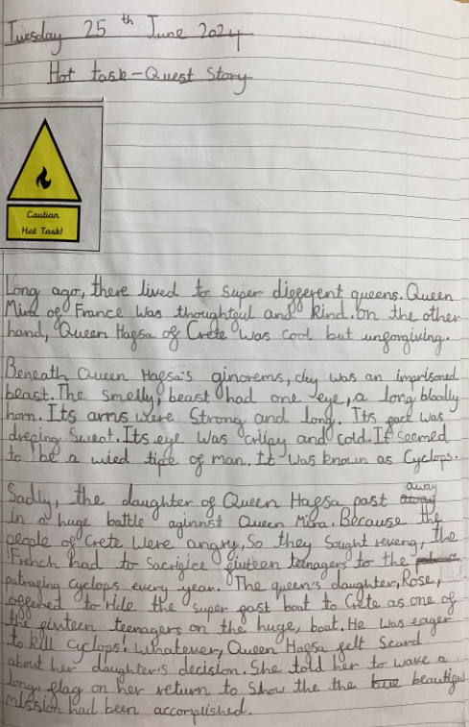

Year 2
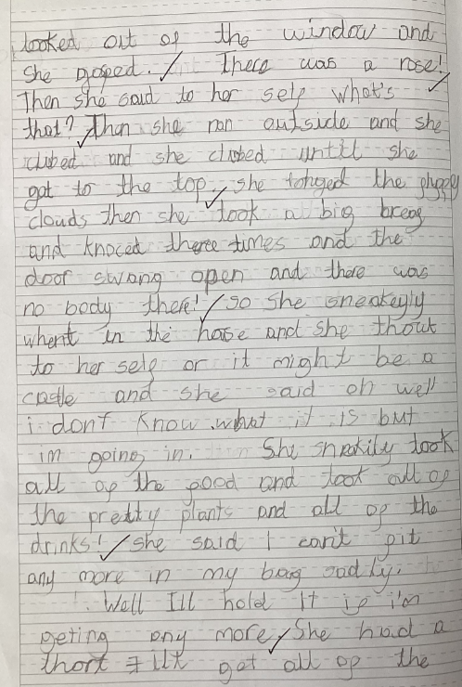

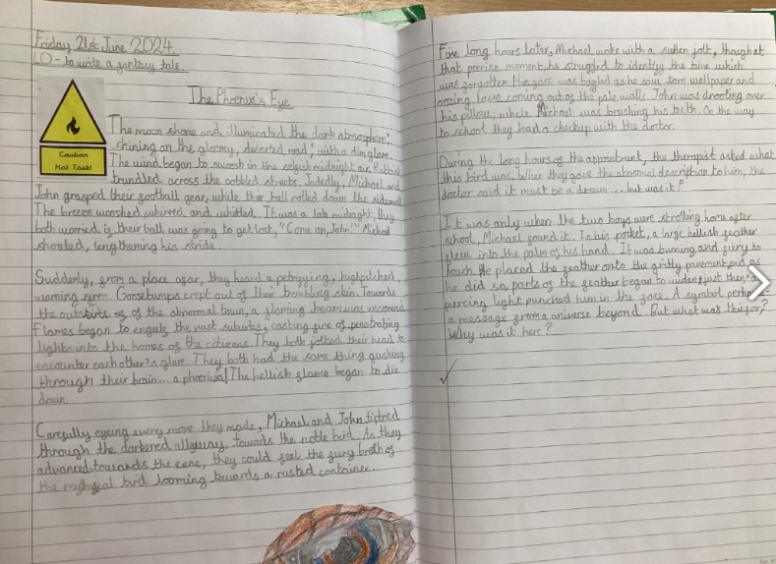
Upper Key Stage 2

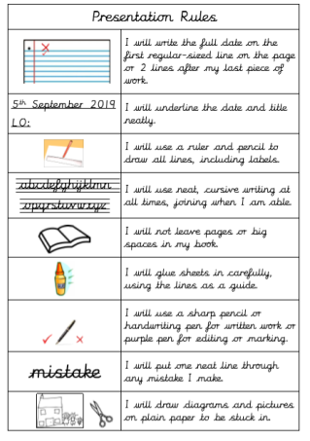

Tuesday 3rd September 2024

