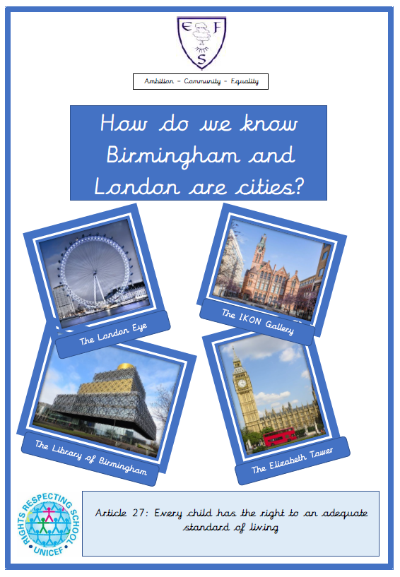

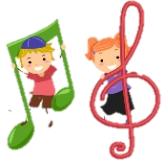
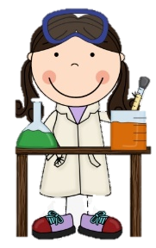
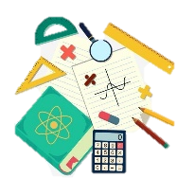
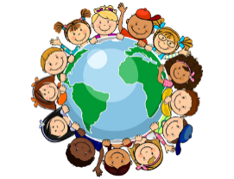
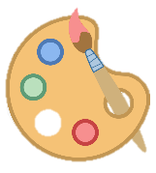
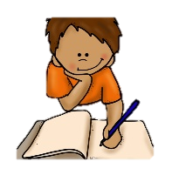
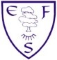
Music
In music, we will be using body percussion and percussion instruments to support of learning of rhythm and pulse.
Computing
In computing this half term, we will be learning the skills of how to paint a picture using age-appropriate software.
PE
This half term’s focus co-ordination and balance and fundamental movement skills in gymnastics.
We will also focus on co-ordination in sending and receiving.

RE
In RE we will be learning all about being fair and just.
PSHE
During PSHE lessons this half term we will be learning about valuing differences in the community and within ourselves.

English
Class texts
Fiction:
The Town Mouse and the Country Mouse
Non-fiction:
The Great Fire of London
Poetry:
Buckingham Palace
Children will be focussing on including adjectives and conjunctions while understanding the beginning, middle and the end of stories.
Maths
This half terms focus is:
Place Value
Addition and Subtraction
Length and Height
Volume and Mass
History
We will be asking a big question: How do we know Birmingham and London are cities? We will be looking at The Great Fire of London.

Geography
We will be learning about key features in our environment such as what makes a city, village and a town. We will also be locating the four countries of the UK and their capital cities.

ART
We will be making sculptures in clay of famous landmarks.
Ambition-Community-Equality
What your child will be learning:
Year 1 Spring Term
Science
In Spring 1our science lessons we will
be learning about the inventors and animal scientists. We will focus on the invention of Lego. We will also focus on the roles of vets and zoo keepers.
In Spring 2, our focus will be everyday materials, distinguishing between an object and the material from which it is made. We will be identifying and naming everyday materials and their properties.

