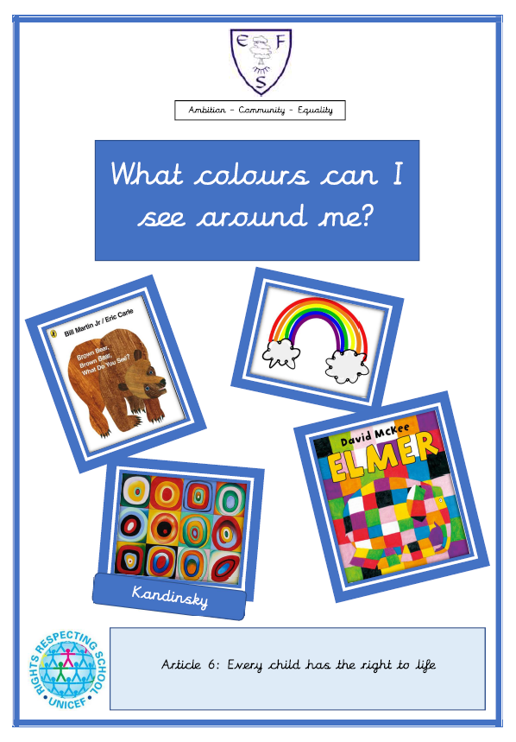

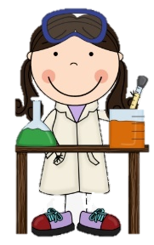
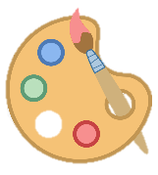
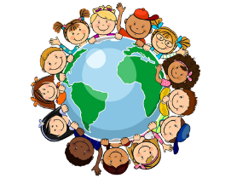
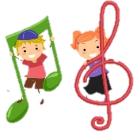
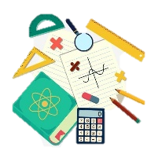
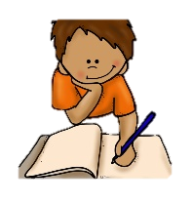
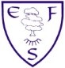
RE
In RE we will be thinking about what is beautiful to me.
PSHE
During PSHE lessons this half term we will be learning why our family and friends are special.

English
Class texts
- Brown Bear, Brown Bear, What do you see?
- Elmer

Children will be learning to repeat familiar songs and phrases from stories and developing play around familiar stories using props.

Maths
This half terms foci are:
- Number 3,4 and 5
- Subitising
- Counting
- Numeral
- Link to shape

Geography
We will be making observation and drawing the environment around us.
History
We will be learning about the time phrase ‘now.’
Art
We will be painting in the style of the artist Kandinsky.
DT
We will be making our own stir fry to celebrate Chinese New Year.

Music
In music, we will be using instruments to make sounds that are loud and quiet.
Computing
In computing this half term we will be learning to draw pictures on an Ipad
PE
This half term’s focus is: Gymnastics

PE lessons will take place on: Friday

Ambition-Community-Equality
What your child will be learning:
Nursery Spring Term 1

Science
In our science lessons we will be talking about the seasonal changes in our environment as we go from Winter to Spring.

