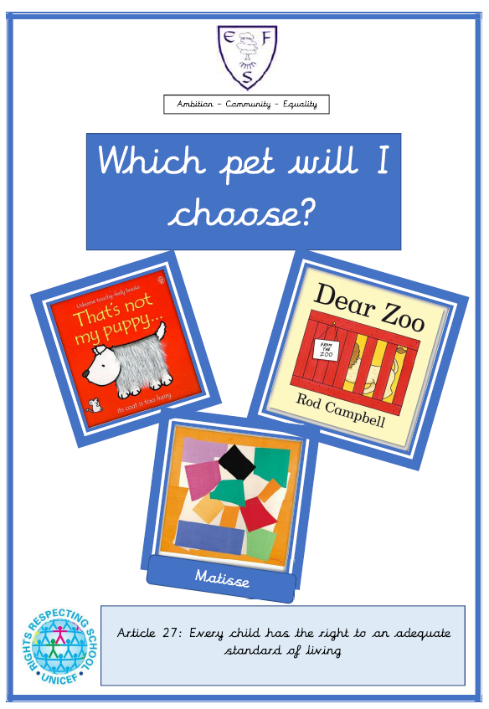
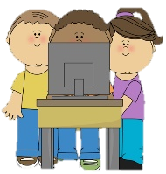
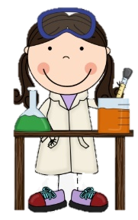
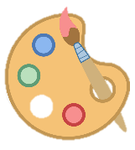
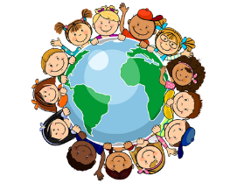
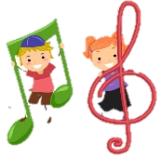
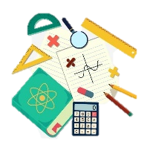
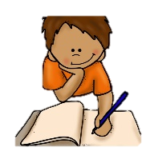
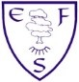
RE
In RE we will learn the Easter story.
PSHE
During PSHE lessons this half term we will learn how to look after ourselves and the environment.

English
Class texts
- That’s not my puppy
- Dear Zoo

Children will be learning to repeat familiar songs and phrases from stories and developing play around familiar stories using props.

Maths
This half terms foci are:
- Number 6 Introduce 10 frame
- Height & Length
- Mass Relate to books
- Capacity

Geography
We will be making observation and drawing the environment around us.
History
We will be learning to create our own time line
Art
We will be creating art work in the style of the artist Matisse
DT
We will be using a range of materials to make our own pet.

Music
In music, we will be using instruments to make sounds that are loud and quiet.
Computing
In computing this half term we will be learning to use the Ipad to take photos
PE
This half term’s focus is: Dance

PE lessons will take place on: Friday

Ambition-Community-Equality
What your child will be learning:
Nursery Spring Term 2

Science
In our science lessons we will be learning to name and draw common animals.

