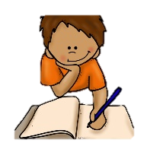
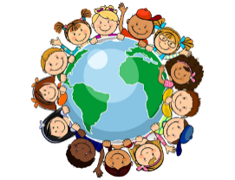

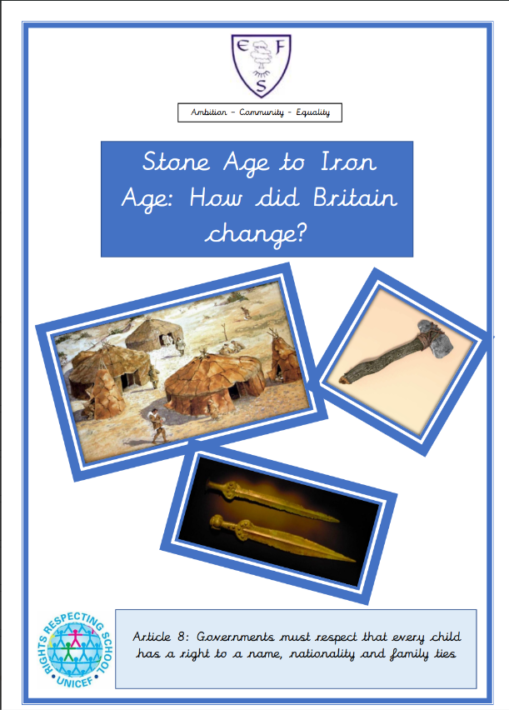
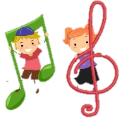
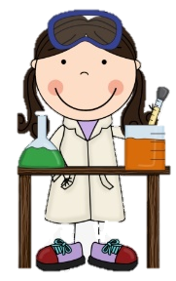
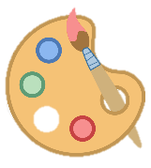
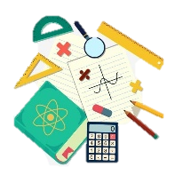
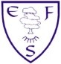
RE
In RE we will be learning about how to be fair and just. Our focus religions are and Islam. Christianity and Sikhism.
PSHE
During PSHE lessons we will learn about our rights and respect.
History
We will be learning about the Stone Age. We will secondary sources to find out what life was like.
Art
We are looking at cave paintings linked to our Stone Age Topic.

English
Class texts
Fiction: Stone Age Boy
Non-fiction: Discovery of Iron Age Chariot (Newspaper Report)
Poetry: Nonsense poem-
On the Ning, Nang, Nong, by Spike Milligan

Children will be learning how to include dialogue in a wishing tale. They will also be learning to write a newspaper report about Stone Age Chariot racers.

Maths
This half term’s foci are:

- Multiply a 2-digit number by a 1-digit number
- Divide a 2-digit number by a 1-digit number
- Measure in metres and centimetres
- Measure in millimetres
- Measure in centimetres and millimetres
- Metres, centimetres and millimetres
- Equivalent lengths (metres and centimetres)
- Equivalent lengths (centimetres and millimetres)
- Compare lengths
- Add length

Music
In music, we will be learning about Pentatonic Melodies.
Computing
In computing this half term, we will be learning about Computing Systems and Networks. We will learn how computers can be connected.
PE
This half term’s focus is Gymnastics.

Ambition-Community-Equality
What your child will be learning:
Year 3 Spring Term 2

Science
In our science lessons, we will learning about Animals, including humans. We will focus on how we can eat a healthy and balanced diet. We will learn about the key food groups and how the body digest foods.

