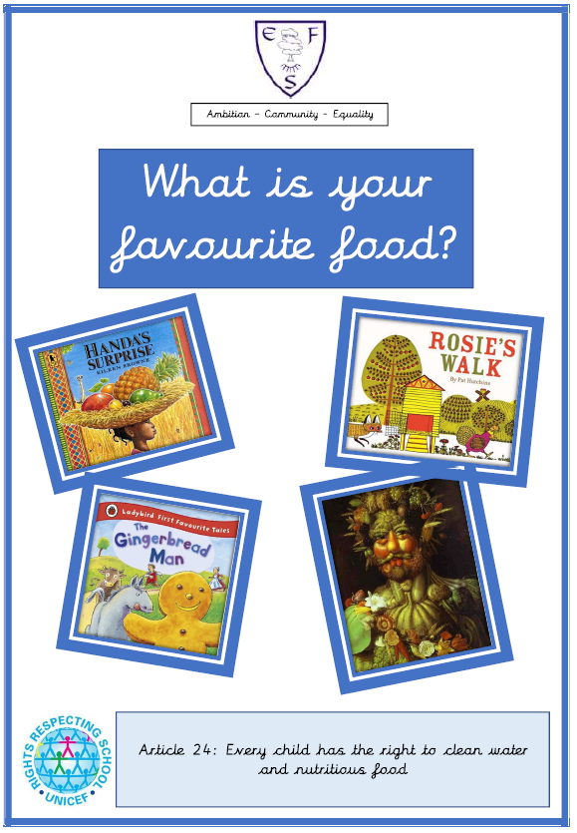


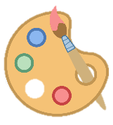

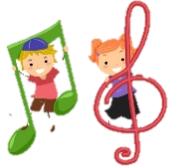
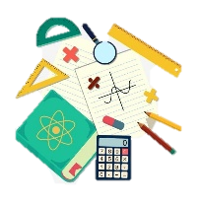
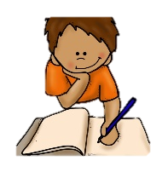

RE
In RE we will be learning about rules that we have at home and school
PSHE
During PSHE lessons this half term we will learn to keep trying and do our best

English
Class texts:
- Rosie’s Walk
- Handa’s Surprise
- The Gingerbread Man

Children will continue to repeat familiar songs and phrases from stories and developing play around familiar stories using props. They will learn to make predictions about a story and suggest what happens next.
Maths
This half terms foci are:
- Sequencing
- Positional Language More than/fewer than
- 2D Shape
- 3D Shape

Geography
We will say what we can see and hear on a nature/listening walk
History
We will be ordering simple pictures to tell a story
Art
We will be creating a piece of artwork in the style of Acrimboldo
DT
We will be chopping our own fruit to make fruit kebabs

Music
In music we will show an interest in the way musical instruments sound
Computing
In computing this half term we will be learning to operate simple equipment such as CD players
PE
This half term’s focus is: Athletics (Sports Day practise)
PE lessons will take place on: Friday

Ambition-Community-Equality
What your child will be learning:
Nursery Summer Term 1

Science
In our science lessons we will be learning what plants need in order to survive and grow. We will also learn that fruit and vegetables are healthy for our bodies.

