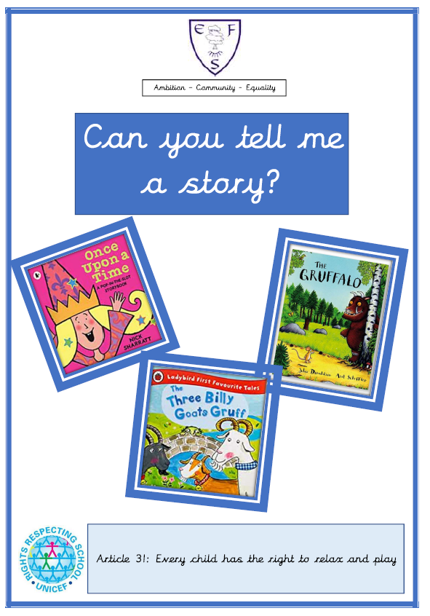

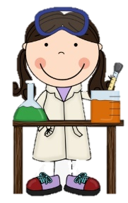
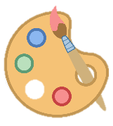
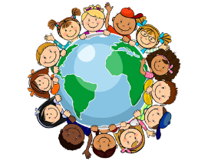
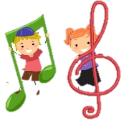
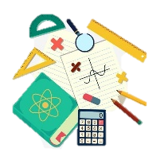
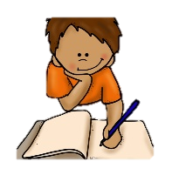
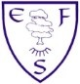
RE
In RE we will be learning what it means to be courageous.
PSHE
During PSHE lessons this half term we will be preparing to move up to Reception.

English

Class texts
- The Gruffalo
- The Three Billy Goat’s Gruff

Children will be learning to repeat familiar songs and phrases from stories and developing play around familiar stories using props. They will also be making predictions about stories.

Maths
This half terms foci are:
- Number composition 1 – 5
- Revision What comes after?
- What comes before?
- Numbers to 5

Geography
We will be describing the things in our environment
History
We will be describing how we have changed over time.
Art
We will be practising all of the skills we have learnt throughout the year.
DT
We will be making structures (bridges) from a range of materials.

Music
In music, we will be describing how a piece of music makes us feel.
Computing
In computing this half term we will be learning to program a remote control toy.
PE
This half term’s focus is: Athletics

PE lessons will take place on: Friday

Ambition-Community-Equality
What your child will be learning:
Nursery Summer Term 2

Science
In our science lessons we will be observing the seasonal changes in our environment as we move from Spring to Summer.

