Rights Respecting Rangers
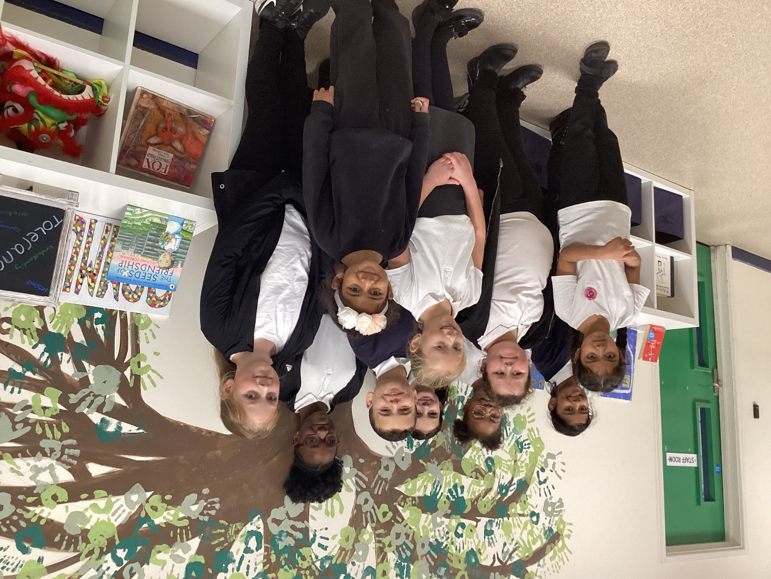
These children will be helping Miss Knight in leading our school towards achieving our Gold Award. They have written some fantastic applications.

