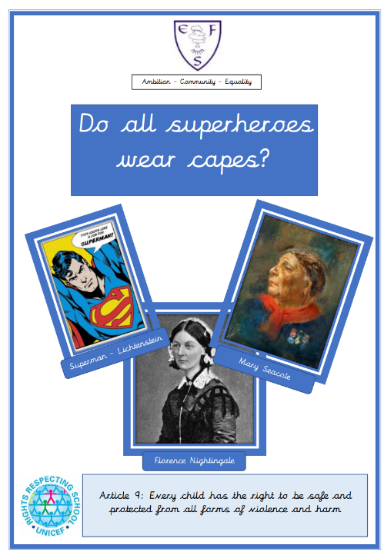


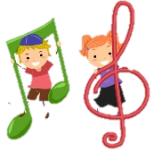





History
We will be asking a big question: Do all Superheroes wear capes?
We will be researching Florence Nightingale, Mary Seacole and John Cadbury, understanding their impact to history. While also researching heroes in our community.
Geography
Our focus is Seasonal Changes, we will identify seasonal and daily weather patterns in the UK and using basic geographical vocabulary to refer to key physical and human features.
ART
Summer 1 – Our artists focus are Andy Goldsworthy and Barbara Hepworth.
Summer 2 – Our artist focus is Roy Lichtenstein
Science
In Summer 1 our Topic in Biology is Plants. We will be identifying and naming a variety of common, wild and garden plants including deciduous and evergreen trees. They will also be describing the basic structures of plants. We will also focus on the roles of vets and zoo keepers.
In Summer 2, our Physics topic is Seasonal Changes. Our focus will be observing the changes across the four seasons while describing the weather associated and the length of the day.
Music
In music for Summer 1 our focus is learning how to identify high and low notes and to compose a simple tune to represent a superhero.
In Summer 2, in this term children will combine all the musical concepts learnt throughout Year 1 for an underwater themed performance including instrumental, vocal and body sounds.
Computing
In computing this term will be using Bee Bots on the Ipads.
PE
Summer – Invasion games
Summer 2 – Athletics and Striking and Fielding

RE
In RE for Summer 1 we will be learning all about ‘Remembering roots’ and ‘Being curious and valuing knowledge’.
In Summer 2 we will be learning all about ‘Being honest and truthful’
PSHE
During PHSE lessons in Summer 1 we will be looking at ‘Super sleep’, ‘Who can help us?’ and ‘Good and bad touches’.
In Summer 2 our focus will be RSHE ‘My friends and me’.
English
Class texts
Fiction:
Summer 1 - Juniper Jupiter
Summer 2 - Ollie and the Wind
Non-fiction:
Summer 1 -Superkid
Summer 2 -Jolly Postman
Poetry:
Summer 1 - Playground rhymes and songs
Summer 2 - A sense of the Weather
Children will be focussing on including adjectives for description of characters and settings, innovating stories and the layout of a letter to a chosen character.
Maths
This terms focus is:
Multiplication and Division
Fractions
Place Value within 100
Money
Time
Ambition-Community-Equality
What your child will be learning:
Year 1 Summer Term

