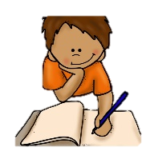
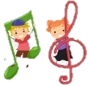

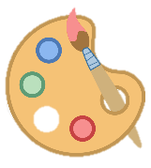
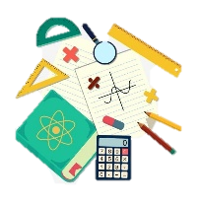
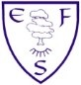
Music
In music, children will be using motifs to explore patterns in music and compose/perform a song as part of our leaver’s assembly.
Computing
In computing, the children will be learning to programme micro bits to create a simple door alarm.
PE
This term’s focus is athletics and rounders. We will also explore leadership strategies to allow the children to develop a range of personal skills.
PE lessons will take place on Tuesdays and Thursdays.

English
Class texts
Fiction: Street Child, Berlie Doherty.
Non-fiction: Discussion texts, Diary entries, Informal/Formal letters.
Poetry: Shakespearean Poetry
Children will be writing a range of independent pieces across a variety of formats that will give them the opportunity to recap and showcase their learning across the year. We will focus on shorter and longer narratives, before exploring discussion texts and both informal/formal letters. These formats will allow children to write independently for a range of purposes.
RE
In RE we will be learning about the importance of being reflective and self-critical, considering how this varies across religions.
PSHE
During PSHE lessons this term we focus on the ways we can be responsible and respectful. This is in line with our rights and responsibilities.

Art
During art, we investigate different printing medias in the Art Nouveau style to create an overprint piece in the style of William Morris.
Ambition-Community-Equality
What your child will be learning:
Year 6 Summer Term

Science
In our science lessons, we will be learning about light sources and the direction/travel of light, focussing on reflection, retraction and shadow. In addition, we also explore the lives and discoveries of Stephen Hawking and Steve Jobs.


Maths
This half term’s foci are:
Properties of shapes
Statistics
Position & Direction
Themed projects
Consolidation
Problem solving



