THIS DOCUMENT IS a statement of the aims, principles and procedures for computing at Elms Farm
Primary School.
IT WAS DEVELOPED in Autumn 2025 through a process of consultation with staff, governors, parents
and Local Authority procedures.
IT WAS APPROVED by the governing body in Autumn 2025
REVIEW: Summer 2028

Our School Values

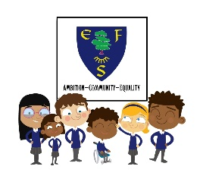
Ambition: We are ambitious for every child to achieve their best and be ambitious about their learning and their future.

Community: We value everyone in our community and learn how to look after each other and our environment. We respect each other and work together.

Equality: We value each other, our beliefs and differences are celebrated. Everyone is treated equally and fairly.


We are a Rights Respecting School
This policy links to the UN Convention for the right of the child:
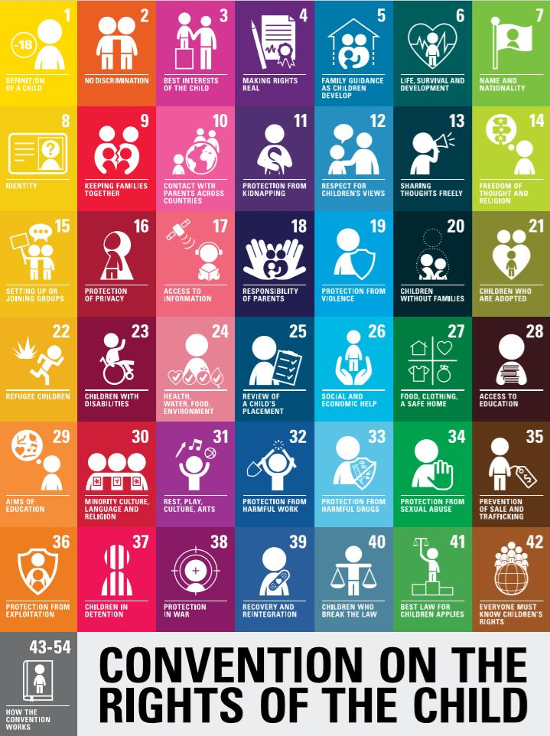

1.PURPOSE

Elms Farm Primary School values Science because it makes an increasing contribution to all aspects of everyday life. All children are naturally curious about their environment and Science is a practical way of finding reliable answers to questions we may ask about the world around us. Science in our school is about developing children’s ideas and ways of working that enable them to make sense of the world in which they live through investigation, as well as using and applying process skills.

2.LEGAL FRAMEWORK

2.1 This policy has due regard to all relevant legislation and statutory guidance including, but not limited to, the following:
- DfE (2021) ‘Keeping children safe in education 2025’
- Data Protection Act 2018
- General Data Protection Regulation (GDPR)
- Equality Act 2010
- DfE (2013) ‘Computing programmes of study: key stages 1 and 2’
2.2 This policy operates in conjunction with the following school policies:
- Health and Safety Policy
- Data and Cyber-security Breach Prevention and Management Plan
- Data Protection Policy
- Pupil Equality, Equity, Diversity and Inclusion Policy
- COSHH Policy
- Primary Teaching and Learning Policy
- Primary Assessment Policy

- 3. ROLES AND RESPONSIBILITIES
3.1 The governing board is responsible for:
- Ensuring a broad and balanced science curriculum is implemented in the school.
- Ensuring the school’s science curriculum is accessible to all pupils.
  - The headteacher is responsible for:
- The overall implementation of this policy.
- Ensuring the school’s science curriculum is implemented consistently.
- Ensuring appropriate resources are allocated to the science curriculum.
- Ensuring all pupils are appropriately supported.
- Appointing a member of staff to lead on the school’s approach to teaching science.
  - The science lead is responsible for:
- Preparing policy documents, curriculum plans and schemes of work for science.
- Reviewing changes to the national curriculum and advising on their implementation.
- Monitoring the learning and teaching of science, providing support for staff where necessary.
- Organising the deployment of resources and carrying out an annual audit of all science resources.
- Leading staff meetings and providing relevant staff with the appropriate training.
- Advising on the contribution of science to other curriculum areas.
  - Science teachers are responsible for:
  - Acting in accordance with this policy.
  - Ensuring that lessons are taught in line with the school’s Health and Safety Policy at all times.
  - Liaising with the science lead about key topics, resources and support for individual pupils if required.
  - Ensuring that all relevant statutory content is covered within the school year.
  - Monitoring the progress of pupils in their class and reporting this on an annual basis.
  - Reporting any concerns regarding the teaching of the subject to the science lead or a member of the SLT.
  - Undertaking any training that is necessary to teach the subject effectively.

- 4. AIMS

- Preparing our children for life in an increasingly scientific and technological world today and in the future.
- Helping our children acquire a growing understanding of the nature, processes and methods of scientific ideas.
- Helping develop and extend our children’s scientific concept of the world.
- Building on our children’s natural curiosity and developing a scientific approach to problems.
- Encouraging open-mindedness, self-assessment, perseverance and developing the skills of investigation – including: observing, measuring, predicting, hypothesising, experimenting, communicating, interpreting, explaining and evaluating.
- Developing the use of scientific language, recording and techniques.
- Developing the use of computing in investigating and recording.
- Making links between Science and other subjects.

5.GUIDELINES:

5.1 Learning & Teaching:
We have common shared principles for Science, which have been agreed by Governors, teaching staff and children. These are displayed in all class rooms. (see below)
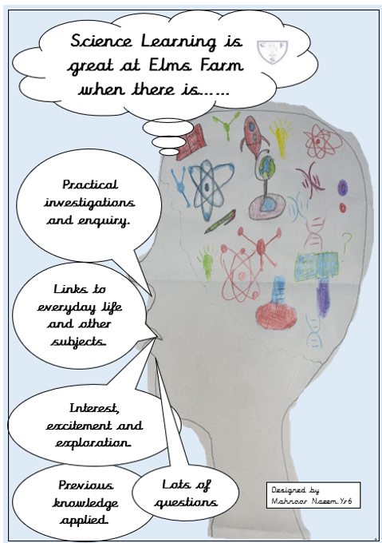

A variety of teaching and learning styles are used in Science lessons. Where possible, Science will be linked to other class topics. Science will be taught as discrete units or lessons where needed to ensure coverage.

Teachers may use materials from the ‘STEM website’, ‘Hamilton Trust’ or ‘Twinkle’ to supplement their planning and teaching.

5.2 Lessons should have clear, specific learning questions/objectives and these should be planned weekly. Working scientifically objectives need to be carefully planned into appropriate lessons. Science investigations should be carried out regularly, at least two every half term to be fully written up, including predictions fair testing, results and conclusion. In addition to this working scientifically skills should be embedded in all weekly lessons.

5.3 Children should be encouraged to work collaboratively in groups to plan out how they are going to carry out their investigation with the resources provided to ensure they take ownership of their investigative work.

5.4 All year groups will ensure a balance between practical skills and knowledge. Children will be given the opportunity to gain confidence and independence in carrying out practical investigations as well as a recording observations, measurements and findings. There is a strong emphasis on the use of mathematical skills in Science. Relevant scientific vocabulary should be displayed and spelt correctly in all classrooms. Displays should also reflect Science teaching and learning.

6 NATIONAL CURRICULM
The national curriculum will be followed for all science teaching.
6.1 during Reception, in accordance with the ‘Early years foundation stage statutory framework: For group and school-based providers’, focus will be put on the seven early learning goals (ELGs), with the scientific aspect of pupils’ work relating to the objectives set out within the framework. The ELGs cover:
- Communication and language: listening, attention and understanding; and speaking.
- Personal, social and emotional development: self-regulation, managing self, and building relationships.
- Physical development: gross motor skills and fine motor skills.
- Literacy: comprehension, word reading, and writing.
- Mathematics: number and numerical patterns.
- Understanding the world: past and present; people, culture and communities; and the natural world.
- Expressive arts and design: creating with materials; and being imaginative and expressive.
During Years 1 and 2, pupils will be taught to:
6.2 Working scientifically
- Ask simple questions and recognise that they can be answered in different ways.
- Observe closely, using simple equipment.
- Perform simple tests.
- Identify and classify.
- Use their observations and ideas to suggest answers to questions.
- Gather and record data to help in answering questions.
Year 1 pupils will also be taught to:
6.3 Plants
- Identify and name a variety of common wild and garden plants, including deciduous and evergreen trees.
- Identify and describe the basic structure of a variety of common flowering plants, including trees.
6.4 Animals, including humans
- Identify and name a variety of common animals, including fish, amphibians, reptiles, birds and mammals.
- Identify and name a variety of common animals that are carnivores, herbivores and omnivores.
- Describe and compare the structure of a variety of common animals, i.e. fish, amphibians, reptiles, birds and mammals, including pets.
- Identify, name, draw and label the basic parts of the human body and say which part of the body is associated with each sense.
6.5 Everyday materials
- Distinguish between an object and the material from which it is made.
- Identify and name a variety of everyday materials, including wood, plastic, glass, metal, water, and rock.
- Describe the simple physical properties of a variety of everyday materials.
- Compare and group together a variety of everyday materials on the basis of their simple physical properties.
6.6 Seasonal changes
- Observe changes across the four seasons.
- Observe and describe weather associated with the seasons and how day length varies.
Year 2 pupils will also be taught to:
6.7 Living things and their habitats
- Explore and compare the differences between things that are living, dead, and things that have never been alive.
- Identify that most living things live in habitats to which they are suited and describe how different habitats provide for the basic needs of different kinds of animals and plants, and how they depend on each other.
- Identify and name a variety of plants and animals in their habitats, including microhabitats.
- Describe how animals obtain their food from plants and other animals, using the idea of a simple food chain, and identify and name different sources of food.
6.8 Plants
- Observe and describe how seeds and bulbs grow into mature plants.
- Find out and describe how plants need water, light and a suitable temperature to grow
- and stay healthy.
6.9 Animals, including humans
- Notice that animals, including humans, have offspring which grow into adults.
- Find out about and describe the basic needs of animals, including humans, for survival, i.e. water, food and air.
- Describe the importance for humans of exercise, eating the right amounts of different types of food, and hygiene.
6.10 Uses of everyday materials
- Identify and compare the suitability of a variety of everyday materials, including wood, metal, plastic, glass, brick, rock, paper and cardboard, for particular uses.
- Find out how the shapes of solid objects made from some materials can be changed by squashing, bending, twisting and stretching.
During Years 3 and 4, pupils will be taught to:
6.11 Working scientifically
- Ask relevant questions and use different types of scientific enquiries to answer them.
- Set up simple practical enquiries, comparative and fair tests.
- Make systematic and careful observations and, where appropriate, take accurate measurements using standard units and a range of equipment, including thermometers and data loggers.
- Gather, record, classify and present data in a variety of ways to help answer questions.
- Record findings using simple scientific language, drawings, labelled diagrams, keys, bar charts and tables.
- Report on findings from enquiries, including oral and written explanations, displays or presentations of results and conclusions.
- Use results to draw simple conclusions, make predictions for new values, suggest improvements and raise further questions.
- Identify differences, similarities or changes related to simple scientific ideas and processes.
- Use straightforward scientific evidence to answer questions or to support their findings.
Year 3 pupils will also be taught to:
6.12 Plants
- Identify and describe the functions of different parts of flowering plants, i.e. roots, stem or trunk, leaves, and flowers.
- Explore the requirements of plants for life and growth, i.e. air, light, water, nutrients from soil, and room to grow, and how requirements vary from plant to plant.
- Investigate the way in which water is transported within plants.
- Explore the part that flowers play in the life cycle of flowering plants, including pollination, seed formation and seed dispersal.
6.13 Animals, including humans
- Identify that animals, including humans, need the right types and amount of nutrition, and that they cannot make their own food; they get nutrition from what they eat.
- Identify that humans and some other animals have skeletons and muscles for support, protection and movement.
6.14 Rocks
- Compare and group together different kinds of rocks on the basis of their appearance and simple physical properties.
- Describe in simple terms how fossils are formed when things that have lived are trapped within rock.
- Recognise that soils are made from rocks and organic matter.
6.15 Light
- Recognise that they need light in order to see things and that dark is the absence of light.
- Notice that light is reflected from surfaces.
- Recognise that light from the sun can be dangerous and that there are ways to protect their eyes.
- Recognise that shadows are formed when the light from a light source is blocked by an opaque object.
- Find patterns in the way that the size of shadows change.
6.16 Forces and magnets
- Compare how things move on different surfaces.
- Notice that some forces need contact between two objects, but magnetic forces can act at a distance.
- Observe how magnets attract or repel each other and attract some materials and not others.
- Compare and group together a variety of everyday materials on the basis of whether they are attracted to a magnet, and identify some magnetic materials.
- Describe magnets as having two poles.
- Predict whether two magnets will attract or repel each other, depending on which poles are facing.
Year 4 pupils will also be taught to:
6.17 Living things and their habitats
- Recognise that living things can be grouped in a variety of ways.
- Explore and use classification keys to help group, identify and name a variety of living things in their local and wider environment.
- Recognise that environments can change and that this can sometimes pose dangers to living things.
6.18 Animals, including humans
- Describe the simple functions of the basic parts of the digestive system in humans.
- Identify the different types of teeth in humans and their simple functions.
- Construct and interpret a variety of food chains, identifying producers, predators and prey.
6.19 States of matter
- Compare and group materials together, according to whether they are solids, liquids or gases.
- Observe that some materials change state when they are heated or cooled, and measure or research the temperature at which this happens in degrees Celsius (°C).
- Identify the part played by evaporation and condensation in the water cycle and associate the rate of evaporation with temperature.
6.20 Sound
- Identify how sounds are made, associating some of them with something vibrating.
- Recognise that vibrations from sounds travel through a medium to the ear.
- Find patterns between the pitch of a sound and features of the object that produced it.
- Find patterns between the volume of a sound and the strength of the vibrations that produced it.
- Recognise that sounds get fainter as the distance from the sound source increases.
6.21 Electricity
- Identify common appliances that run on electricity.
- Construct a simple series electrical circuit, identifying and naming its basic parts, including cells, wires, bulbs, switches and buzzers.
- Identify whether a lamp will light in a simple series circuit, based on whether the lamp is part of a complete loop with a battery.
- Recognise that a switch opens and closes a circuit and associate this with whether a lamp lights in a simple series circuit.
- Recognise some common conductors and insulators, and associate metals with being good conductors.
During Years 5 and 6, pupils will be taught to:
6.22 Working scientifically
- Plan different types of scientific enquiries to answer questions, including recognising and controlling variables where necessary.
- Take measurements, using a range of scientific equipment, with increasing accuracy and precision, taking repeat readings when appropriate.
- Record data and results of increasing complexity using scientific diagrams and labels, classification keys, tables, scatter graphs, bar and line graphs.
- Use test results to make predictions to set up further comparative and fair tests.
- Report and present findings from enquiries, including conclusions, causal relationships, and explanations of the results and the degree of trust in them, in oral and written forms such as displays and other presentations.
- Identify scientific evidence that has been used to support or refute ideas or arguments.
Year 5 pupils will also be taught to:
6.23 Living things and their habitats
- Describe the differences in the life cycles of a mammal, an amphibian, an insect and a bird.
- Describe the life process of reproduction in some plants and animals.
6.24 Animals, including humans
- Describe the changes as humans develop to old age.
6.25 Properties and changes of materials
- Compare and group together everyday materials on the basis of their properties, including their hardness, solubility, transparency, conductivity (electrical and thermal), and response to magnets.
- Know that some materials will dissolve in liquid to form a solution, and describe how to recover a substance from a solution.
- Use knowledge of solids, liquids and gases to decide how mixtures might be separated, including through filtering, sieving and evaporating.
- Give reasons, based on evidence from comparative and fair tests, for the particular uses of everyday materials, including metals, wood and plastic.
- Demonstrate that dissolving, mixing and changes of state are reversible changes.
- Explain that some changes result in the formation of new materials, and that this kind of change is not usually reversible, including changes associated with burning and the action of acid on bicarbonate of soda.
6.26 Earth and space
- Describe the movement of the Earth, and other planets, relative to the Sun in the solar system.
- Describe the movement of the Moon relative to the Earth.
- Describe the Sun, Earth and Moon as approximately spherical bodies.
- Use the idea of the Earth’s rotation to explain day and night and the apparent movement of the Sun across the sky.
6.27 Forces
- Explain that unsupported objects fall towards the Earth because of the force of gravity acting between the Earth and the falling object.
- Identify the effects of air resistance, water resistance and friction that act between moving surfaces.
- Recognise that some mechanisms, including levers, pulleys and gears, allow a smaller force to have a greater effect.
Year 6 pupils will also be taught to:
6.28 Living things and their habitats
- Describe how living things are classified into broad groups according to common observable characteristics and based on similarities and differences, including microorganisms, plants and animals.
- Give reasons for classifying plants and animals based on specific characteristics.
6.29 Animals, including humans
- Identify and name the main parts of the human circulatory system, and describe the functions of the heart, blood vessels and blood.
- Recognise the impact of diet, exercise, drugs and lifestyle on the way their bodies function.
- Describe the ways in which nutrients and water are transported within animals, including humans.
6.30 Evolution and inheritance
- Recognise that living things have changed over time and that fossils provide information about living things that inhabited the Earth millions of years ago.
- Recognise that living things produce offspring of the same kind, but normally offspring vary and are not identical to their parents.
- Identify how animals and plants are adapted to suit their environment in different ways and that adaptation may lead to evolution.
6.31 Light
- Recognise that light appears to travel in straight lines.
- Use the idea that light travels in straight lines to explain that objects are seen because they give out or reflect light into the eye.
- Explain that we see things because light travels from light sources to our eyes or from light sources to objects and then to our eyes.
- Use the idea that light travels in straight lines to explain why shadows have the same shape as the objects that cast them.
6.32 Electricity
- Associate the brightness of a lamp or the volume of a buzzer with the number and voltage of cells used in the circuit.
- Compare and give reasons for variations in how components function, including the brightness of bulbs, the loudness of buzzers, and the on or off position of switches.
- Use recognised symbols when representing a simple circuit in a diagram.

7. MARKING AND FEEDBACK
All Science work should be quality marked. Practical Science and investigative work may also be evidenced through the use of photos with annotations in books. Please see the Marking and Feedback policy for further information.

7.1 All relevant staff are briefed on the school’s lesson planning procedures as part of staff training.
Throughout the school, science is taught as a discrete lesson and as part of cross-curricular teaching when appropriate. The statutory national curriculum content from the DfE’s ‘Science programmes of study: key stages 1 and 2’, as outlined above, as the starting point for their planning.

7.2 Lesson plans will balance visual, auditory and kinaesthetic elements used in teaching, ensuring that all pupils with different learning styles can access the learning experience. All lessons will have clear learning objectives, which are shared and reviewed with pupils.

7.3 Long-term planning will be used to outline the units to be taught within each year group. Medium-term planning will be used to outline the vocabulary and skills that will be taught in each unit of work, as well as highlighting the opportunities for assessment, identifying learning objectives, main learning activities and differentiation. Short-term planning will be used flexibly to reflect the objective of the lesson, the success criteria and the aim of the next lesson, building on medium-term planning and taking into account pupils’ needs.

8. ASSESSMENT AND TARGET SETTING
Pupil’s work will be assessed in line with the Assessment Policy and the use of Topic tests at the end of each unit of work. The results will be used to inform teacher assessment.

8.1 Pupils will be assessed and their progression recorded in line with the school’s Primary Assessment Policy. Assessment in science will be based upon scientific knowledge and understanding.

8.2 Pupils will be assessed continually throughout the year and will undertake a summative assessment at the end of each academic year. Formative assessment will be carried out informally throughout the year. This will enable teachers to identify pupils’ understanding of subjects and inform their immediate lesson planning. The results of end-of-year summative assessments will be passed to relevant members of staff, such as the pupil’s future science teacher.

8.3 Assessment will take various forms, including the following:
• Talking to pupils and asking questions
• Discussing pupils’ work with them
• Marking work against learning objectives
• Specific assignments for individual pupils
• Observing practical tasks and activities
• Pupils’ self-evaluation of their work
• Classroom tests

8.4 Parents will be provided with a written report about their child’s progress during the Summer term every year. Reports will include information on the pupil’s attitude towards science, progress in understanding scientific methods, ability to investigate, and the knowledge levels they have achieved. Verbal reports will be provided at parent-teacher meetings during the Autumn and Spring terms.

9. RESOURCES
Science resources are stored in the science cupboard. Each class teacher can present receipts to the office, after permission is given, for ‘consumable’ items needed to support the Science curriculum.

9.1 Equipment will be checked by the relevant science teacher prior to each use and any damages or defects will be reported to the science lead immediately. Staff will also inform the science lead of any changes regarding science resources, such as when supplies of resources have run out or new resources are required. The science lead is responsible for negotiating requests from staff and ensuring resources are bought within the amount allocated in the annual budget.

10 HEALTH AND SAFETY
Staff will act in accordance with the school’s Health and Safety Policy at all times.
10.1 A risk assessment will be carried out by teachers before higher-risk science-related activities, e.g. conducting an experiment or undertaking practical activities.
10.2 All science teachers and other relevant staff will be shown how to correctly use science equipment as part of their induction training. Staff will also be made aware of the COSHH and RIDDOR regulations as part of their induction training and will act in accordance with these whilst undertaking activities.
10.3 All pupils will be shown how to correctly use equipment prior to use and will be monitored by staff whilst using equipment. Pupils will also be made aware of how they are expected to behave, ensuring that they show respect to other people and the environment, and the personal safety protocols and protective equipment needed when using equipment or carrying out tasks, e.g. goggles.
10.4 At the beginning of any experiment, the science teacher will outline the purpose of the experiment to the class, and all hazards and safety precautions will be thoroughly outlined. Any experiments or activities not previously conducted by the science teacher will be trialled prior to being undertaken with pupils.
Accidents and near-misses will be reported following the school’s reporting procedures.
11. EQUAL OPPORTUNITIES
All pupils will be given equal access to the entire science curriculum, including practical experiments.
11.1 Where required, pupils with SEND will be provided with additional support in order to fully engage with the science curriculum.
11.2 Where it is inappropriate for a pupil to participate in a specific lesson because of reasons related to any protected characteristics, the lesson will be adapted to meet the pupil’s needs and alternative arrangements involving extra support will be provided where necessary.
11.3 The school aims to provide more academically able pupils with the opportunity to extend their scientific thinking through extension activities such as problem solving, investigative work and scientific research.

12. MONITORING
Termly monitoring of books and pupil voice. Whenever possible lesson observations will take place.

